Data Technician Workbook
Week 1: Excel

Name:
Course Date:
Table of contents
Day 1: Task 1 2
Day 2: Task 1 2
Day 2: Task 2 3
Day 2: Task 3 4
Day 3: Task 1 4
Day 3: Task 2 5
Dataset: 5
Step 1: Create a Pivot Table 5
Step 2: Use the SWITCH Function 5
Submission: 6
Day 3: Task 3 6
Day 4: Task 1 7
Course Notes 9
Additional Information 10

Day 1: Task 1

Please research and complete the boxes below on common laws and regulations that must be followed when working with customers' data, and use the below bulleted list to support your answers.

- What is it
- Why is it important
- Provide a real-world example of how you can follow it
- How does it impact working with data
- What could happen if you breached it

Data Protection Act | This act provides guidance for how organisations should collect, use, store and share customers’ personal information in a safe manner. For instance, a company might have a customer’s personal information in their database such as their name, address, phone number. It is the company’s responsibility to ensure that that data is safe from anyone unlawfully gaining access and using it for fraudulent purposes for example. There must be adequate controls in place to ensure it is accessed by trained staff and using processes and systems according to data protection laws. If there are any breaches it might affect the company’s brand image and lead to loss of trust by the customers. Other implications could entail financial penalties and costly lawsuits. (Source – https://www.gov.uk/data-protection/the-data-protection-act)
GDPR | The UK General Data Protection Regulation explains how organisations should go about collecting, using, storing and protecting personal data of people such as their name, telephone numbers and banking details. The focus is on ensuring the data is safe, that they use it responsibly while protecting the persons privacy. For example, students’ science test results containing the name and surname as well as their mark cannot be disposed of in general bins for disposal. We would need to remove details of that learner and either shred that page of place it into confidential waste paper bins that get disposed of by an official company following the guidance protocols. Only certain staff can have access to student information. The is a multifactor authentication system that one would need to sign onto to access any student information and there is a trail on excel spreadsheets should details of who amended results etc. As with the DPA, any breaches could result in large fines for the organisation, damage to their brand reputation  (Source – https://ico.org.uk/for-organisations/uk-gdpr-guidance-and-resources/  - https://www.legislation.gov.uk/eur/2016/679/contents)
Freedom of Information Act | This act allows the general public to ask authorities (example councils, schools or emergency services) for any recorded information they hold about how they make decisions or spend public money. The idea is that there is transparency, accountability and openness from the organisation to disclose this information. For example, if a school has been receiving funding for learners from a disadvantaged background, the public can ask for that school to show how it has used that funds allocated to that portion of learners. The school would not give personal information of the learners but might submit proof of funding for trips or interventions making up that amount. Data that can be legally released is shared correctly otherwise data that is confidential or has personal data cannot be released. Consequences for breaches might include complaints being raised, investigation being conducted or legal action being taken. (Source - https://ico.org.uk/for-organisations/)

Day 2: Task 1

Please research and complete the following tasks within the retail-sales_dataset.xlsx document, and paste a print screen into the provided boxes below:

- In the sheet ‘retail_sales_dataset’, add all available data between columns A – H into a ‘table’ using Ctrl+T. Then name the table.
- Using the ‘filter’ function, filter ‘Age’ from ‘largest to smallest’
- Using the ‘SUM’ function, show me the commission total in cell ‘P10’
- Using the ‘AVERAGE’ function, show me the average commission in cell ‘P11’

Print screen 1 | 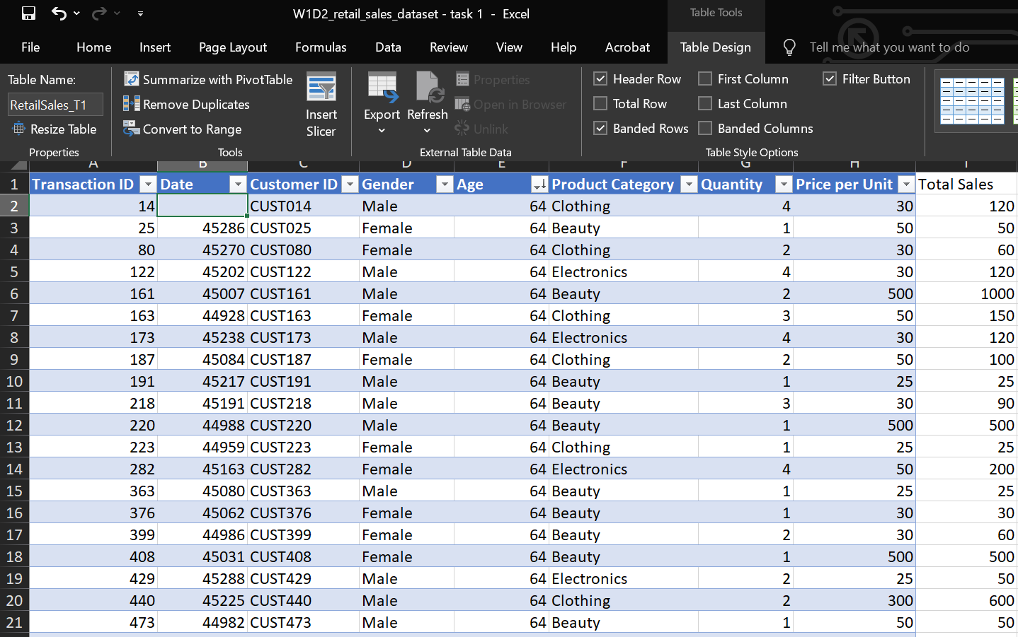
Print screen 2 | 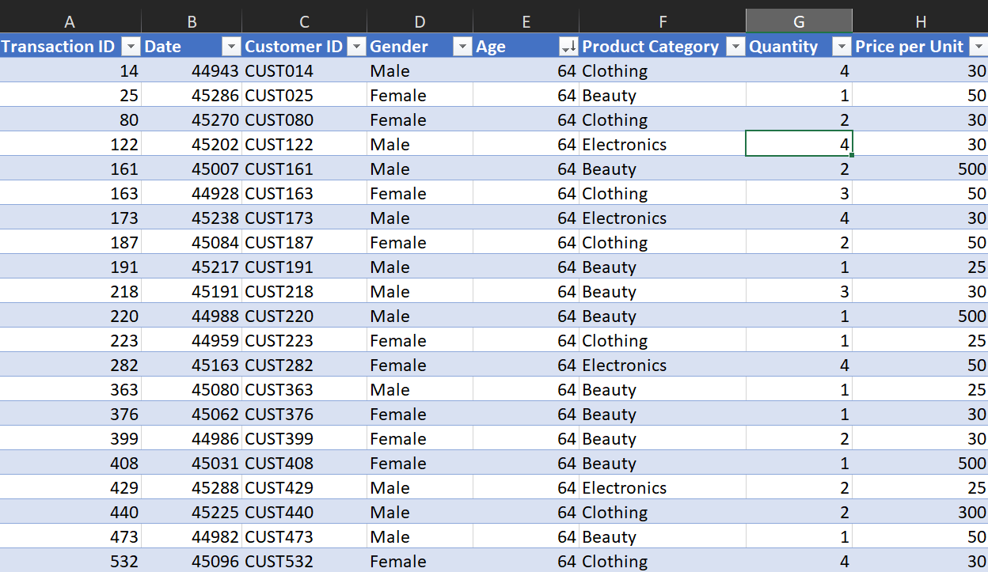
Print screen 3 | 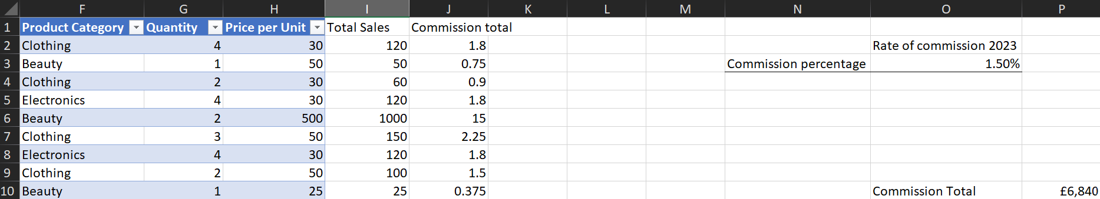
Print screen 4 | 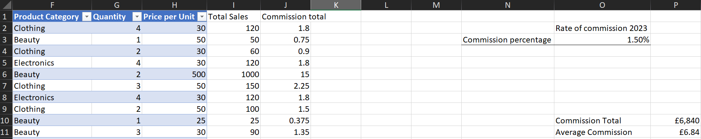

Day 2: Task 2

Please research and complete the following tasks within the document, and paste print screens into the provided box below:

Use the Student grades table provided by the tutor,

Convert the table to an Excel table. (Ctrl +T)

Student name | English | Mathematics | Science | Average | Highest score
Carol | 75 | 85 | 85
Khan | 85 | 75 | 80
Harry | 80 | 70 | 80
Sarah | 80 | 70 | 80
John | 65 | 80 | 70
Linda | 90 | 50 | 70
Edward | 55 | 80 | 60
Mary | 55 | 70 | 65
Thomas | 55 | 30 | 65

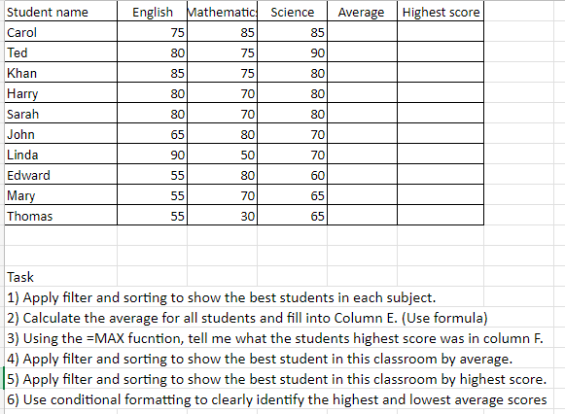

Print screen 1
- 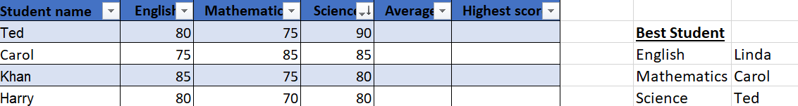

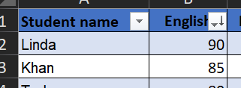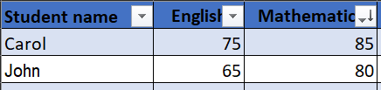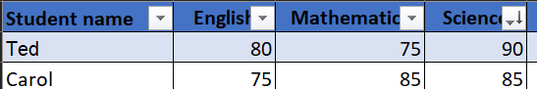

- 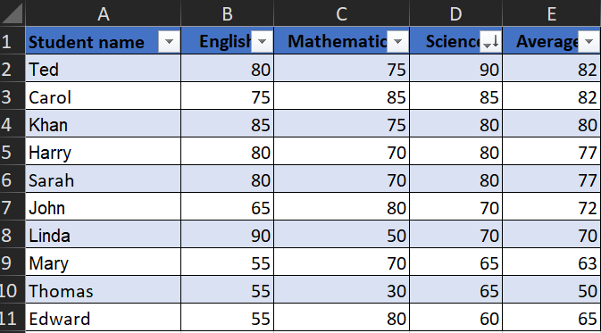

- 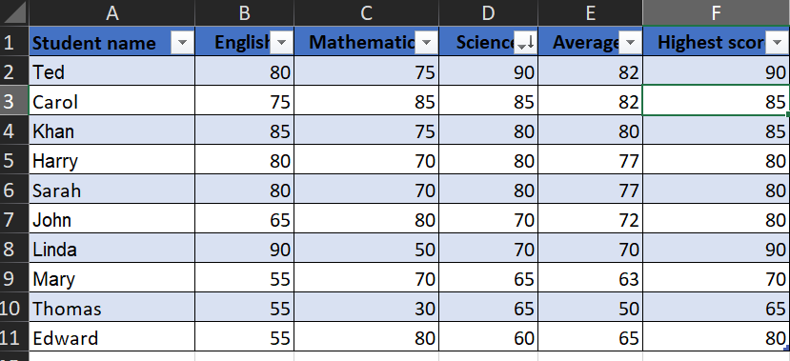

- 

- 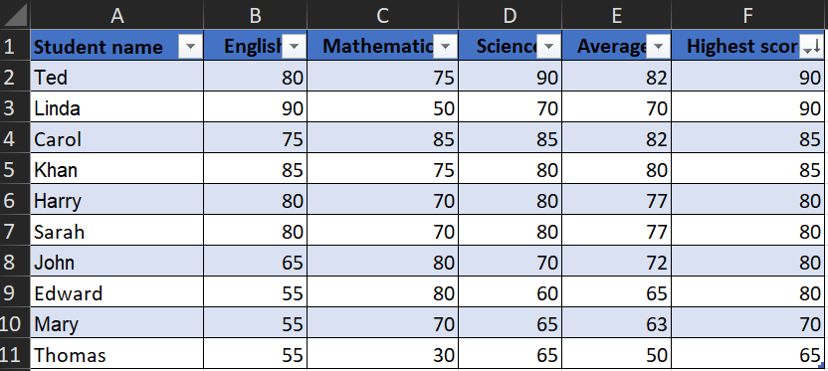

- 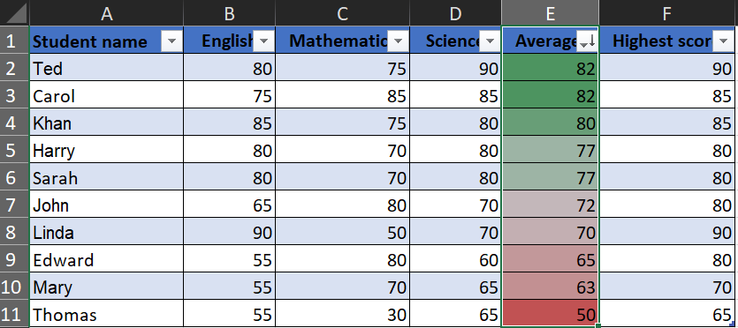

Summary of all the tasks:

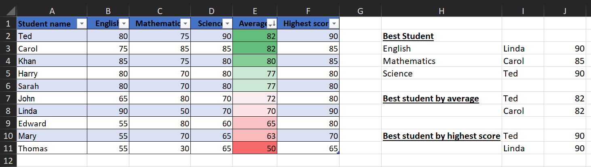

Day 2: Task 3

Using the skills developed today, have some fun with the data set you have imported. Paste your work below and enjoy!

Print screen 1

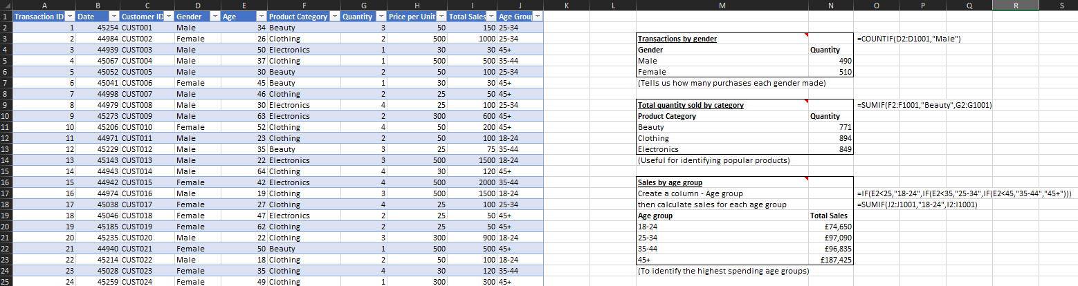

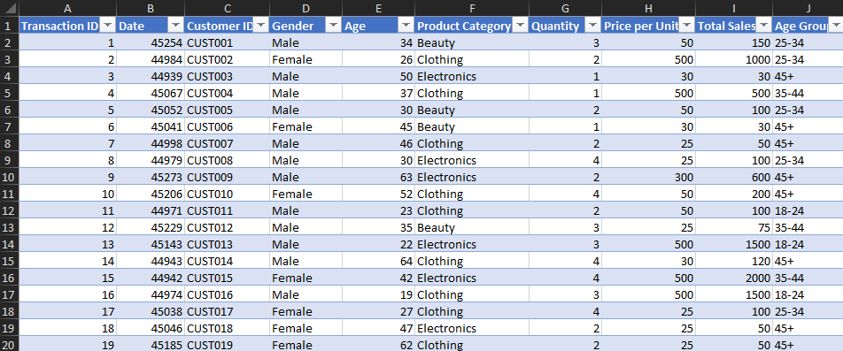

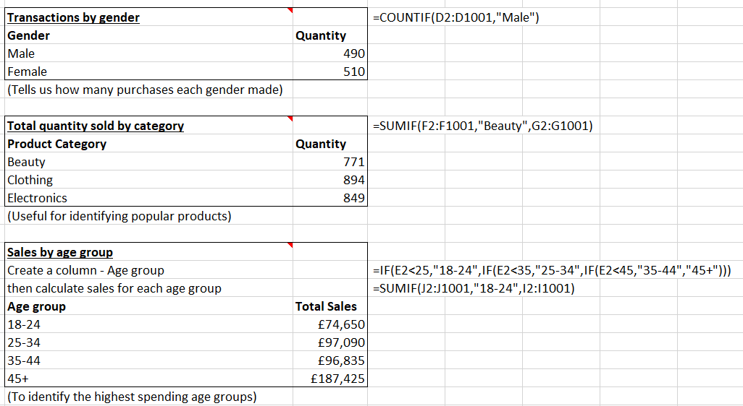

Day 3: Task 1

Dataset: Day_3_Task_1_Bike_Sales_Pivot_Lab.xlsx. and,
Lab instructions: Lab pivot table use for task 1 instructions

Make a copy of the dataset. Use the copy.

Convert to Excel Table (Ctrl +T)

Follow the lab instructions. Do not worry if you do not complete the lab; just working with data and playing with the pivot table will be a good experience.

Note:
Under refine the pivot table:
To mask 0's.
Click the pivot table
Click the Pivot Table Analyse tab on the menu bar.
Options > options > layout and format> In the field for empty cells, select the checkbox and enter 0 (zero). Ok.

And for the reflection questions, please do them in your workbook, not in the lab.

Please paste your final pivot table below and complete the reflection questions:

Print screen 1 | 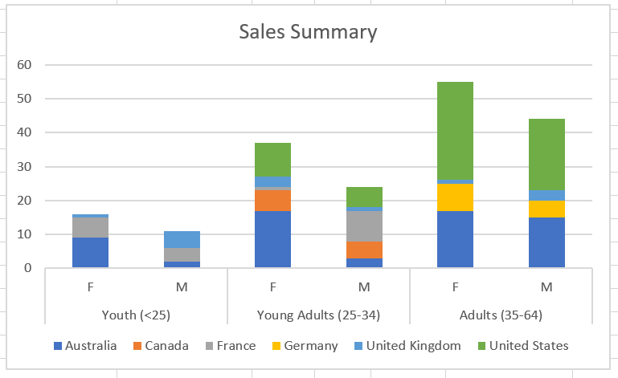  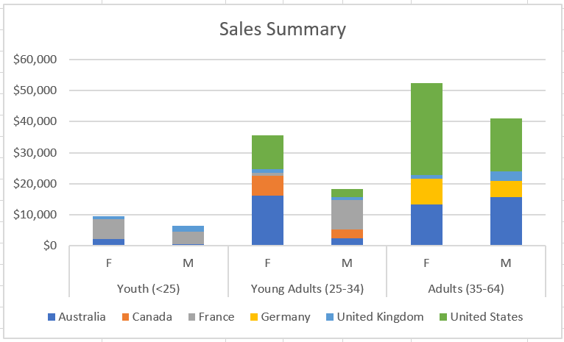
In which markets does Germany have customers? | Germany has customers in the adults between 35 to 64 years old category.
What country has sales in all markets? | Australia and United Kingdom have sales in all markets.
What are the most profitable markets by country, age group, and gender? | United States was the most profitable market by country with a profit of $60,370.  Age group (35-64) was the most profitable at $93,496.  Females were the most profitable market by gender with a profit of $97,543.
Any other findings? | I noticed the following:  - Some of the fields for United States had spaces resulting in three different country listings so I had to clean the data first before I h=could continue.  - Some fields had null values which meant that I had to use the function to convert nulls to zero.

Day 3: Task 2

The dataset below tracks the sales performance of different products in various counties in England. Please paste the dataset into a blank Excel workbook. Your task is to:
- Create a Pivot Table to summarise the data by county and product.
- Use the SWITCH function to categorise products based on their sales volume.
See instructions below.

The dataset can be found in the last workbook you used.

County | Product | Sales Volume
Yorkshire | Laptops | 500
Yorkshire | Smartphones | 200
Cornwall | Laptops | 700
Cornwall | Printers | 400
Lancashire | Smartphones | 150
Lancashire | Laptops | 600
Essex | Printers | 800
Essex | Smartphones | 300
Durham | Laptops | 250
Durham | Printers | 300
Greater Manchester | Smartphones | 600
Greater Manchester | Laptops | 400

Dataset:

Step 1: Create a Pivot Table
- Select the dataset (columns A to C).
- Insert a Pivot Table to summarise the data by County in the rows and Products in the columns. Use Sales Volume as the value to be summarised.

Step 2: Use the SWITCH Function
In a new column next to your data, use the SWITCH function to categorise products based on Sales Volume as follows:
For sales greater than 600: "High"
For sales between 300 and 600: "Medium"
For sales less than 300: "Low"

SWITCH Function Example:
=SWITCH(TRUE, C2 > 600, "High", C2 >= 300, "Medium", "Low")

- Apply this formula to each row, and check if the products are categorised correctly.
- In ‘Sales Volume’, you need to remove the space after each amount – hidden spaces
- Confirm the data type is numerical

Submission:
- A completed Pivot Table summarising sales by county and product.
- A new column in the dataset categorising products by sales volume using the SWITCH function.
  - Please paste your completed work below

Print screen 1 | 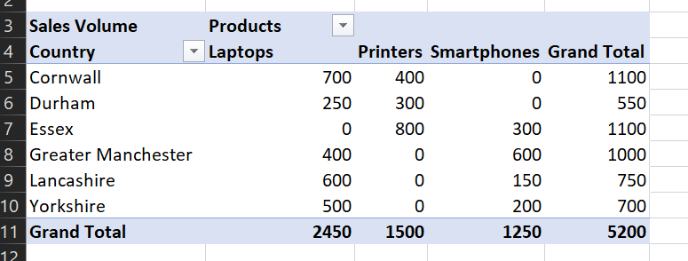  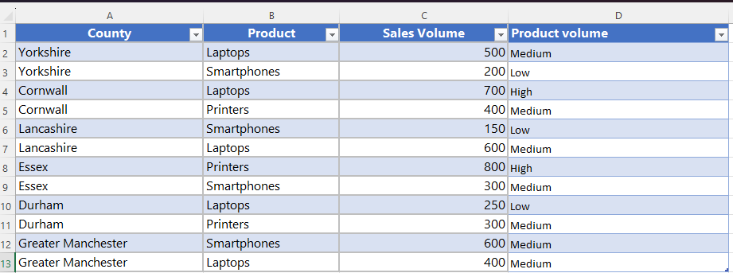

Day 3: Task 3

Please download the dataset ‘Day_3_Task_3_Bike_Sales_Visualisations_Lab.xlsx’.
Also, download the lab instructions.

Pivot tables are already created; you will need to create the pivot charts.

Follow the lab instructions.

Do not worry if you do not complete the lab; just working with data and playing with the charts will be a good experience.

Please paste your results below:

Print screen 1

Day 4: Task 1

You have been asked to deliver your analysis findings to the board of directors. Within your analysis, you have identified that customers are leaving your company at the 12-month point, which is typically when they receive their renewal price.

Choose a business or organisation to focus your findings on.

Conduct research and complete the following questions:

As in all work situations, you can use AI Gen tools for research: it needs to be in British English, check spelling, grammar and maths; and written in your voice, not copied directly from the tool.

How would you prepare for the delivery? | The scenario we chose was SKY Broadband customers opting to leave us instead of renewing their subscription after 12 months. As I would be presenting to the Board of Directors, I need to be mindful that I need to have accurate, relevant and reliable data to substantiate any analysis findings. I would do some work into understanding what the directors’ priorities might be and tailor my recommendations to align to that.  I would pay attention to creating a logical structure to how I would be presenting to the board. The purpose of the meeting is to show that we are losing customers at the renewal point. So, I would need to look at my data and see what is best to show this loss. What the business impact would be might entail getting data showing financial impacts as well as looking at it from a marketing or customer satisfaction survey and brand loyalty. I would then make recommendations and use forecasting or What if analysis to show how discounted renewals might impact revenue.  I would practice delivering the presentation several times to improve my confidence, timing and pace of my presentation. Further I would prepare answers to possible questions that might be asked about my data or visualisations that was presented. I probably would do a trial run with my senior leader with the hope of finding areas of improvement or opportunities.
What tools would you use for the delivery? | I would use Power point to present my analysis findings and to keep the audience focused on just the key information. Charts, graphs, summaries and company branding themes can be added for relevance and professionalism.  Microsoft excel is what I would use to prepare and analyse the data and then use that information to create charts and Pivot tables  Teams or Zoom could be used if there are any board members that are attending remotely via video conferencing.
What is prospecting, and why would you complete this before your delivery? | Prospecting is the process where you gather information that you think will be useful for your interaction with whomever you are going to be meeting with. The idea is that what you will present points that are relevant, easy for them to understand, what they would consider priorities as they will use this to make business decisions. For the SKY Broadband scenario, I will need to think about what data and visuals to use showing why the customers are leaving, how it will affect sales, and potentially have some ideas or suggestions around how to improve customer retention prior to the 12 months renewal point in case they pose the question to me during the meeting.  (Source – mindtools.com/ah0fzyv/audience/)
Tell me the best practices for public speaking and providing updates to senior leaders | The idea is that you would want to quickly get the attention of the audience by doing the following:  - Using simple language  - Speaking clearly, confidently and at a steady pace  - Presenting yourself professionally and neatly  - Start with the main point so they do not have to wait a long time for it  - Do not read off slides but rather talk about the relevant evidence on visual aids eg. Powerpoint slides  - Having an idea of the duration of the presentation and make time for questions and answers.  (source – Mindtools.com/ajclj5u/delivering-great-presentations/)
What will you show the board in your delivery? | For my scenario, I would put together a powerpoint slide with information that I will talk through. I will try using the brand colour formatting for any visuals and background formatting.  There would be a title slide explaining the purpose of the presentation. This would be followed by an executive summary that would show data supporting the view that customers are leaving SKY Broadband after receiving their 12 month renewal price. Subsequent slides could show some analyses such as decrease in customer numbers by number of months, decrease in revenue. I would definitely include slide showing reasons for the loss of customers which might include competitors with better offers or customer satisfaction reports showing that they might not feel value or despair and reduced rates for new customers while existing customers have to pay the increased price to retail the product. The last slides will include recommendations we could put in place to retain the customer such as rewarding loyal customers with a personalised percentage renewal discount. My concluding slide will be an invitation for any questions from the board.  (source – winningpresentations.com/how-to-present-to-board-of-directors/  V Shepherd – Leepgroup technical trainer)
How will you articulate the changes that are needed? | While displaying the data and visuals, so that the board can follow along, I will show step by step how the data would suggest that customers leave after they receive notification of their 12 months renewal price. I will talk through comparisons of acquiring new customers versus retaining existing customers as well as show the so-called loss of offering personalised renewal discounts compared to the set-up costs for acquiring new customers. A slide showing our competitors pricing and benefits for new customers compared to our pricing for existing customers should be further evidence for justifying taking action to retain our customers. All being said, by explaining the problem, the evidence and suggesting how to retain customers, in a way the board can follow and understand, it might be a step they would pursue to retain the customers before they look elsewhere.  (Source winningpresentations/change-management-presentation/)
Provide a list of online resources and videos that will support your preparation for public speaking | Videos: Youtube  How to speak more confidently and persuasively | Matt Abrahams https://www.youtube.com/watch?v=LpbBzmXrzEY&t=41s  Toastmasters https://www.youtube.com/@toastmasters/videos  Linkedin Learning  https://learning.linkedin.com/free-courses
Evaluate tools that provide visualisation.  Tell me what they are.  Tell me what you would choose when delivering your presentation and why | Visualisation tools that I have used are Microsoft Excel and power point and most recently I have been learning Power BI.  I would most likely use power point for its professional format and ease of manoeuvring through slides that will contain the graphs, charts and pivot tables created in Excel.  I am not sure how interactive it would be though as in Excel I could use Pivot tables and What if analysis.

Course Notes

It is recommended to take notes from the course, use the space below to do so.

Additional Information

We have included a range of additional links to further resources and information that you may find useful, these can be found within your revision guide.

END OF WORKBOOK

Please check through your work thoroughly before submitting and update the table of contents if required.

Please send your completed work booklet to your trainer.

